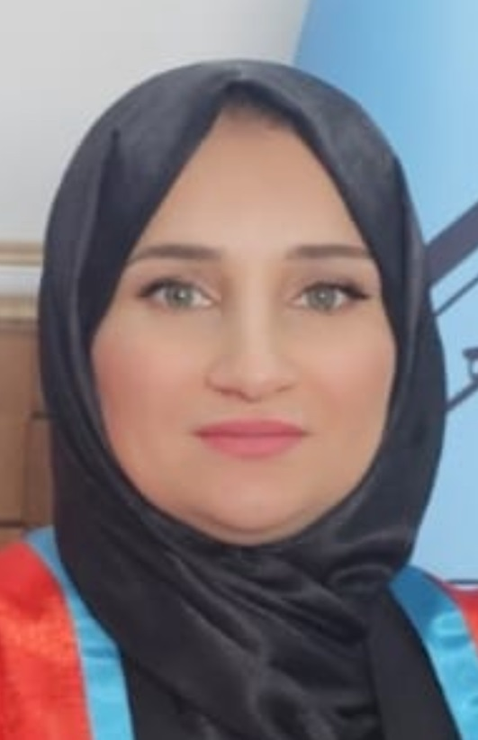 |  | haliz saddeq hasan  University Lecturer
Profile  Auto-adjust  Contact  PHONE:  07504426526  EMAIL:  haliz.hasan@uod.ac  Hobbies  Exercises  Study |  | certificate  Bachelors in microbiology, University of Mosul, College of Science, Iraq  2004-2005  M. Sc. in molecular biology, University of Duhok, College of Medicine, Kurdistan/Iraq  2013-2014  Thesis title: Procalcitonin Expression in Human Cord Blood Mononuclear cells as a Marker of Bacterial Infection Estimated by ELISA and RT-PCR Techniques  Ph. D. in medical microbiology, University of Duhok, College of Medicine, Kurdistan/Iraq  From 2024  Scientific title  lecturer, University of Duhok, College of Medicine, Iraq  2024  training courses  A course in Teaching methods, University of Duhok  2014  A course in English, preintermediate level, university of Duhok, language center  18/1/2023  A course in English, intermediate level, university of Duhok, language center  31/5/2023  researches  - ASSOCIATION OF COMPLEMENTFACTOR H GENE (CFH) SINGLE NUCLEOTIDE POLYMORPHISM WITH RECURRENT APHTHUS STOMATITIS  2018  - Molecular Detection of Virulence Factors and Antibiotic Resistance among Enterococcus Species Isolates from Kurdistan Region of Iraq. 2024  - Molecular Detection of Virulence Factors and Antibiotic Resistance among Enterococcus Species Isolates from Kurdistan Region of Iraq. 2024

