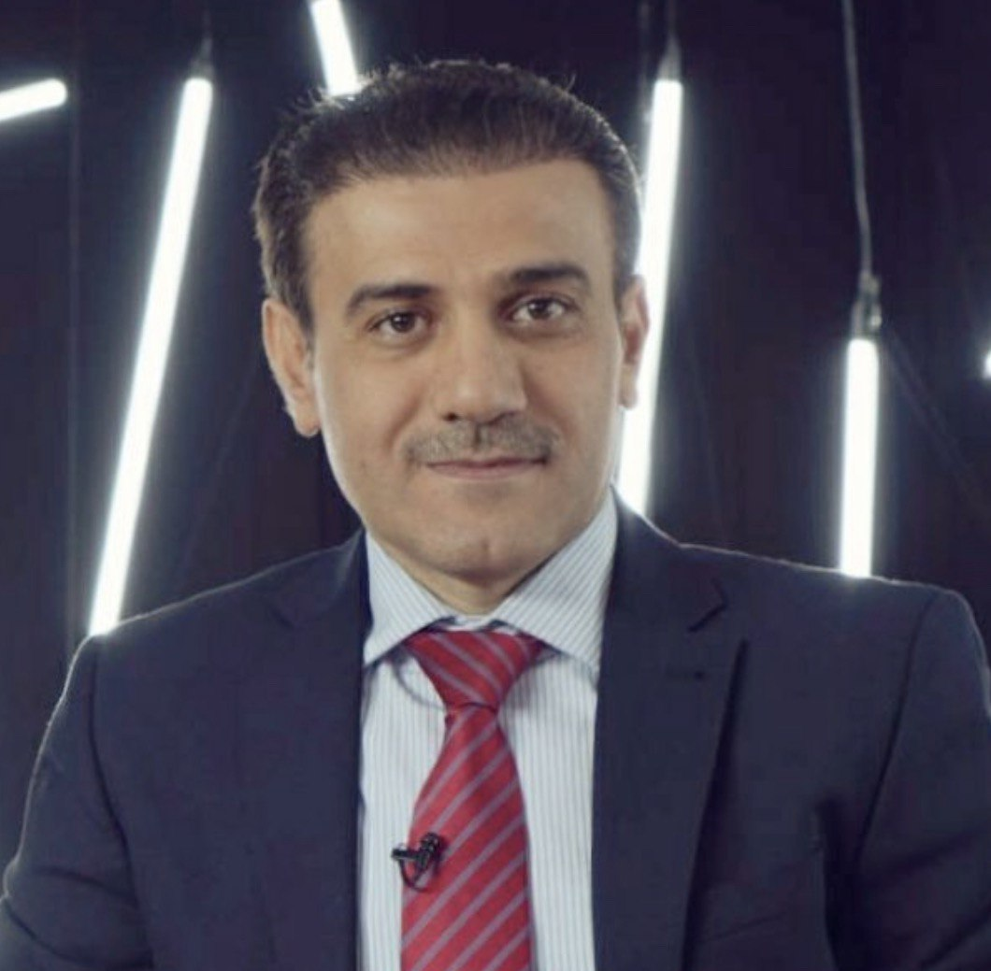
CURRICULUM VITAE (CV)
Assistant (Associate) Prof. Dr Omran Omer Ali

Email: omran.ali@uod.ac
Tel: 009647504949220
Date of Birth: 01/03/78
Nationality: Iraqi

Research Interests: International Relations, European Union External Policies and Human Rights and International Politics.

Education:
2017 PhD in Politics, Unexpected Effectiveness? The European Union and the Long Journey to the 2015 Landmark Agreement on Iran’s Nuclear Programme, University of Glasgow, UK.
2012-2013 MRes Human Rights and International Politics, The European Union as a Promoter of Democracy and Human Rights, University of Glasgow, UK.
2003-2005 M.Sc. in Political Science, The Impact of Culture on Foreign Policy: the United States as a Case Study, Al-Neelain University, Khartoum, Sudan.
1997-2001 B.Sc. in Political Science, The Impact of Globalization on Culture: Kurdistan Region as a Case Study, University of Salahaddin, Erbil,Iraq.

Employment and Work Experience:
2020- Head of the Department of International Relations and Diplomacy, College of Political Science, University of Duhok, Kurdistan Region, Iraq. Responsible of scientific affairs and development of the Department.
2020- Assist. Prof., Faculty of Law, Political Science and Management/ Postgraduate Program, Soran University, Kurdistan Region, Iraq. Lecturing postgraduate (Master) students in International Relations Theories, with particular focus on structural realism.
2020- Assist. Prof, Department of Political Science, College of Law, University of Duhok, Kurdistan Region, Iraq. Lecturing postgraduate (Master) student in Research Methods for Political Science and Theories of International Relations, and Contemporary Theory in International Relations.
2021 Assist. Prof, Department of International Studies, American University of Kurdistan (AUK), Duhok, Kurdistan Region, Iraq. Lecturing undergraduate students in International Relations Theory and Democracy and Civil Society.
2017- Lecturer, Department of Political Science, College of Law and Political Science, University of Duhok, Kurdistan Region, Iraq. Lecturing undergraduate students in International Relations Theories, Global Politics, Political Thought, Political Theory and Political Development, as well as supervising the theses of fourth year students.
2017- Lecturer, Department of International Relations, College of Law and Politics, Nawroz University, Kurdistan Region, Iraq. Lecturing undergraduate students in International Relations: Principles and Theories, and Political Geography.
2019 Lecturer, Department of Public Policy, University of Duhok, Kurdistan Region, Iraq. Lecturing undergraduate students in International Relations Theories.
2006-11 Assist. Lecturer, College of Law and Political Sciences, University of Dohuk, Kurdistan Region, Iraq, Lecturing undergraduate students in
International Organizations, Human Rights, and Kurdish Studies, as well as supervising the theses of fourth year students.
2007-8 Department Director, Department of Law, College of Law and Political Science, University of Duhok, Kurdistan Region, Iraq, assisting the Head of Department.
2014- Adviser (consultant), Kurdish Knowledge Centre (KKC), Glasgow/Scotland/ United Kingdom, advising on: Iraqi Kurdish affairs, EU-Kurdish relations and Human rights and international politics.
2016- 20. Interpreter/ Translator, Govan and Craigton Integration Network (GCIN)/ Voiceover Interpreting, Glasgow/Scotland/United Kingdom, Interpreting and Translating from Kurdish/Arabic to English and vice versa.
2020- Participating in multiple PhD and Master Vivas and discussions.
2006- Participating in multiple domestic and international conferences in various topics.

Publications:
Ali, O. (2021) International interventions in non-democratic states between democratic change and achieving interests (Iraq as a case study after 2003). Conference Paper. University of Human Development/ Sulaymaniah. 1415/7/2021.
Ali, O. (2021) The Impact of the Transatlantic relationships on Iran’s role in the middle east, Conference Paper. International conference on the Role of Iran in the Middle East after the Vienna Negotiations. Middle East Political and Economic Institute with Cihan University Duhok. June 1, 2021.
Ali, O. (2020) Conflict and Cooperation in International Relations: Theoretical
Contributions of the Debate between New Realism and Neoliberalism, Humanities Journal of University of Zakho, 8: 4, pp. 659-670, https://doi.org/10.26436/hjuoz.2020.8.4.653
Ali, O. (2019) From critical to comprehensive dialogue: the effectiveness of the
EU's policy towards Iran (1992-1998), British Journal of Middle Eastern Studies, December/ 2019,
(ID: 1701408 DOI:10.1080/13530194.2019.1701408)
Ali, O. (2019) The Impact of EU-Iran Relations on the Effectiveness of the US's Sanctions policy towards Iran, Journal of Asian Issues, 1:1, pp. 21-40.
Ali, O. (2018) The European Union as a Normative Power: The Case of the EU's Foreign Policy towards Turkey, Journal of the University of Duhok, 21:2, pp. 63-79. https://doi.org/10.26682/hjuod.2019.21.2.40
Ali, O. (2018) 'The Diplomacy of Empathy in International Relations: the Case of Iran's Nuclear Negotiations (2003-2015)', Journal of University of Human Development, 4:3, pp. 79- 92. Ali, O. (2011) ‘Regional Government’s External Relations in the Federal system: Kurdistan Regional Government as a case study’, Conference Paper, published, Journal of the University of Duhok, 14:2, pp. 247-263, special issue.
Ali, O. (2011) ‘The Impact of Religion on Relationships between the United States and Israel’, Journal of the University of Duhok, 14:2, pp. 245261.(Published in Arabic language).
Ali, O. (2010) ‘The Role of Non-Government Actors in International Relations’, Journal of the University of Duhok, 13:2, pp. 109-129 (Published in Arabic language)
2001- Numerous articles in various subjects published in different Kurdish and Arabic newspapers and magazines.
2001- Multiple papers and seminars conducted in work with various local NGOs in Kurdistan region.

Languages: English, Arabic and Kurdish (Badini and Sorani)

Books
- International Relations: A study of mainstream and critical theories, 2019. (Arabic Language)
- International Relations: A study of mainstream and critical theories, 2019.
(Kurdish Language)
Working Papers
  - The implications of the transatlantic relations on Iran’s nuclear issue (2003-2015)
  - US pressure policy and sanctions to change Iran's behavior
  - Building stability in Iraq: The Monopoly of the Legitimate Use of Force.
  - The Element of Fear in Realism: Critical Perspective.
Working Books
1₋ Kurdish Issue and Politics of International Powers (1916-2016) 2₋ Balance of Power: History, Policies and Cases.

